Chapter 10 homework

- Complete exercises 10.7, 10.11, 10.17, 10.27 (use examine.mod.multiple.final.R; for part b, you do not need to complete the formal normality test; for part d, replace the dot plot with the plot created by examine.mod.multiple.final), and 9.27 on model validation
- Examine tests from 2012
- Reproduce all examples in the notes

Partial answers:

10.7
a.

> #Read in the data
> patient<-read.table(file = "C:\\chris\\UNL\\STAT870\\Instructor_CD\\Data
Sets\\Chapter 6 Data Sets\\CH06PR15.txt", header = FALSE,
col.names = c("satisfaction", "age", "illness", "anxiety"), sep = "")
> head(patient)
satisfaction age illness anxiety
1 48 50 51 2.3
2 57 36 46 2.3
3 66 40 48 2.2
4 70 41 44 1.8
5 89 28 43 1.8
6 36 49 54 2.9

> mod.fit<-lm(formula = satisfaction ~ age + illness + anxiety, data = patient)
> sum.fit<-summary(mod.fit)
> sum.fit

Call:
lm(formula = satisfaction ~ age + illness + anxiety, data = patient)

Residuals:
Min 1Q Median 3Q Max
-18.3524 -6.4230 0.5196 8.3715 17.1601

Coefficients:
Estimate Std. Error t value Pr(>|t|)
(Intercept) 158.4913 18.1259 8.744 5.26e-11 ***
age -1.1416 0.2148 -5.315 3.81e-06 ***
illness -0.4420 0.4920 -0.898 0.3741
anxiety -13.4702 7.0997 -1.897 0.0647 .
---
Signif. codes: 0 '***' 0.001 '**' 0.01 '*' 0.05 '.' 0.1 ' ' 1

Residual standard error: 10.06 on 42 degrees of freedom
Multiple R-Squared: 0.6822, Adjusted R-squared: 0.6595
F-statistic: 30.05 on 3 and 42 DF, p-value: 1.542e-10

> ############################################################################
> # Part a
>
> #Added variable plots
> library(car)
> av.plots(model = mod.fit, ask=FALSE, one.page = TRUE, identify.points=FALSE)

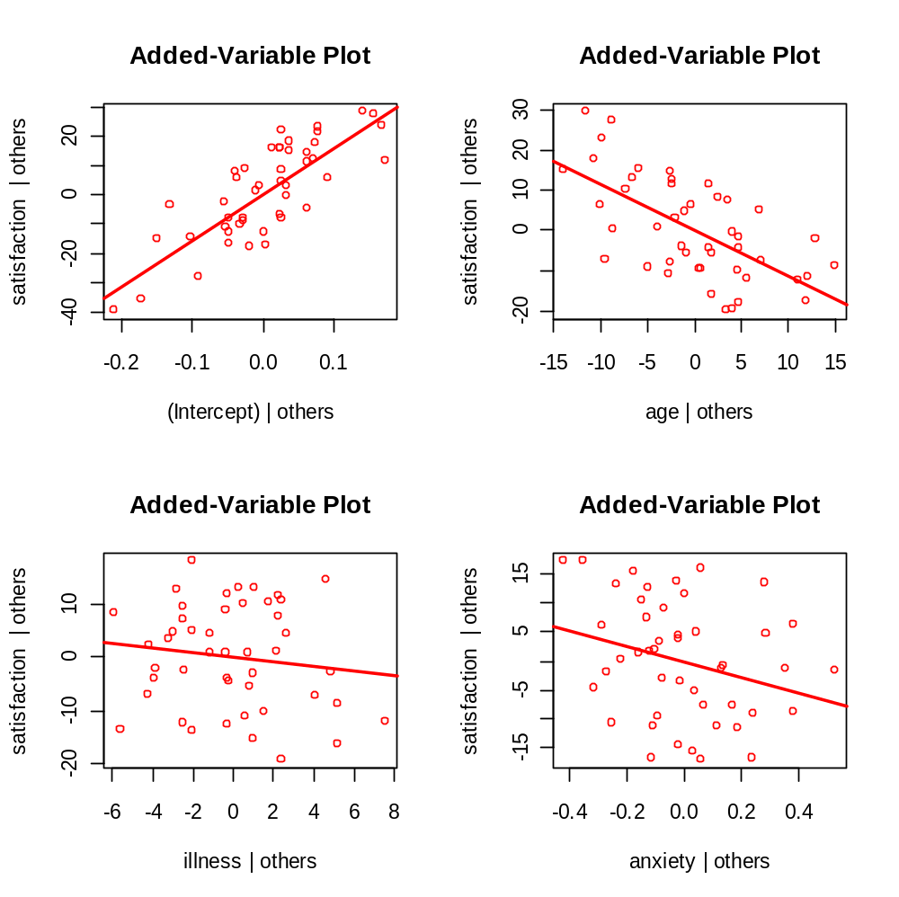

b. No – the plots indicate linear relationships.

10.11 Answer key:
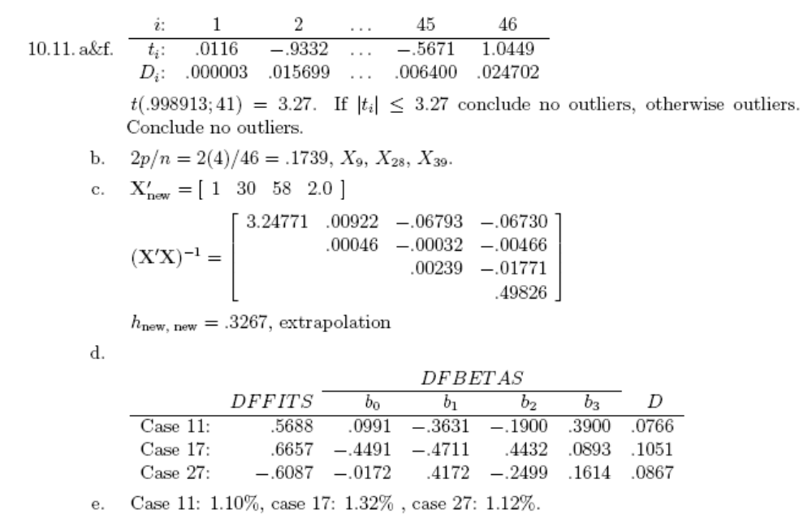

a. Conclude outlier if greater than 3.27.

> #Critical value
> n<-length(mod.fit$fitted.values)
> qt(p = 1-0.10/(2*n), df = mod.fit$df.residual-1)
1] 3.271524

> #t.i vs. Y.hat.i
> plot(x = mod.fit$fitted.values, y = t.i, xlab = "Estimated mean response",
ylab = "Studentized deleted residuals", main = expression(paste(t[i], "
vs. estimated mean response")), panel.first = grid(col = "gray", lty =
"dotted"), ylim = c(min(qt(p = 0.05/(2*n), df = mod.fit$df.residual-1),
min(t.i)), max(qt(p = 1-0.05/(2*n), df = mod.fit$df.residual-1),
max(t.i))))
> abline(h = 0, col = "darkgreen")
> abline(h = c(qt(p = 0.01/2, df = mod.fit$df.residual-1),qt(p = 1-0.01/2, df =
mod.fit$df.residual-1)), col = "red", lwd = 2)
> abline(h = c(qt(p = 0.10/(2*n), df = mod.fit$df.residual-1),qt(p = 1-
0.10/(2*n), df = mod.fit$df.residual-1)), col = "darkred", lwd = 2)
> identify(x = mod.fit$fitted.values, y = t.i)
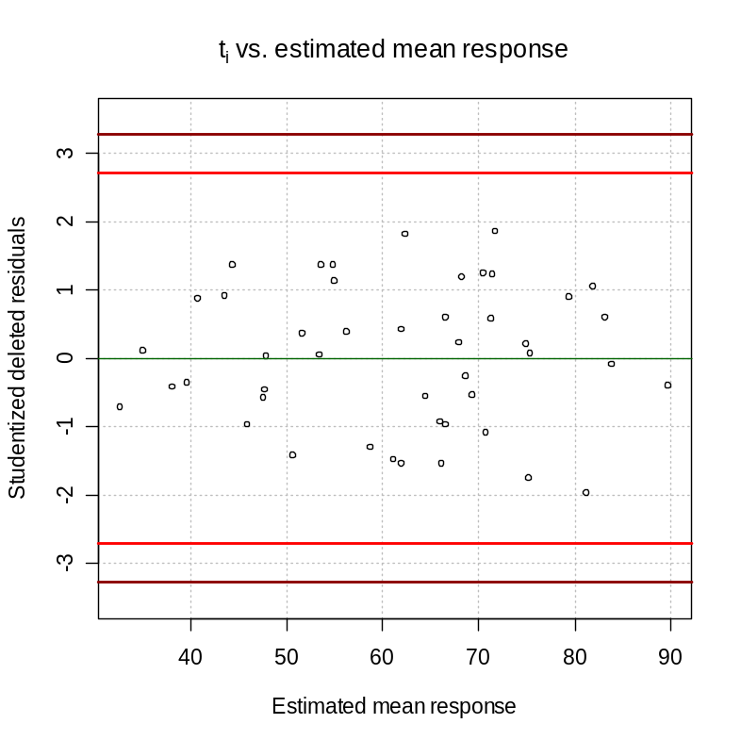

No values outside of the limits.

> #Fox's outlier.test() function
> outlier.test(mod.fit)

max|rstudent| = 1.974202, degrees of freedom = 41,
unadjusted p = 0.05512149, Bonferroni p > 1

Observation: 27

The p-value is > 1 due to the adjustment made by the Bonferroni procedure. Of course, probability values can not be greater than 1!

b.

> h.ii<-hatvalues(model = mod.fit)
> p<-length(mod.fit$coefficients)
> n<-length(mod.fit$residuals)
> round(h.ii[h.ii>2*p/n],2)
9 28 39
0.18 0.19 0.18

> plot(x = 1:n, y = h.ii, ylab = expression(h[ii]), xlab = "Observation number",
main = expression(paste("Index plot of ", h[ii])))
> abline(h = 2*p/n, col = "red", lty = "dashed")
> abline(h = c(0.2,0.5), col = "blue", lty = "dotted")
> identify(x = 1:n, y =h.ii)
[1] 9 28 39
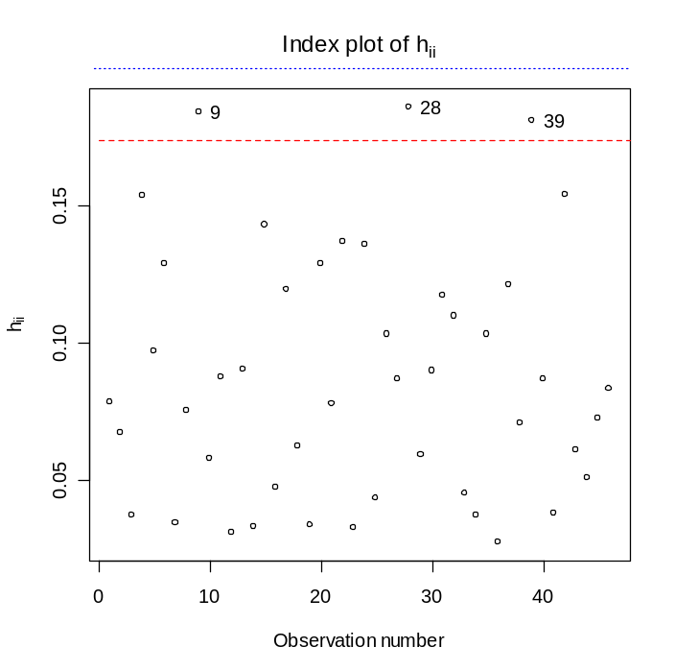

- Possibly yes due to h_{new,new} being much larger than the other h_{ii} values for those observations in the data set.

> #See p. 400
> X.new<-c(1, 30, 58, 2)
> X<-as.matrix(cbind(1, patient[,2:4])) #Need as.matrix() so that R treats it
like a matrix for its calculations
> h.new.new<-t(X.new)%*%solve(t(X)%*%X)%*%X.new
> h.new.new
[,1]
[1,] 0.3267004

> summary(h.ii)
Min. 1st Qu. Median Mean 3rd Qu. Max.
0.02723 0.04808 0.08067 0.08696 0.11890 0.18600

d.
DFFITS are not too far past the “large” data sets borderline. Cook’s D does not have any values past the quantile from the F-distribution. Some DFBETAS are passed the borderline for the “large” data set criterion.
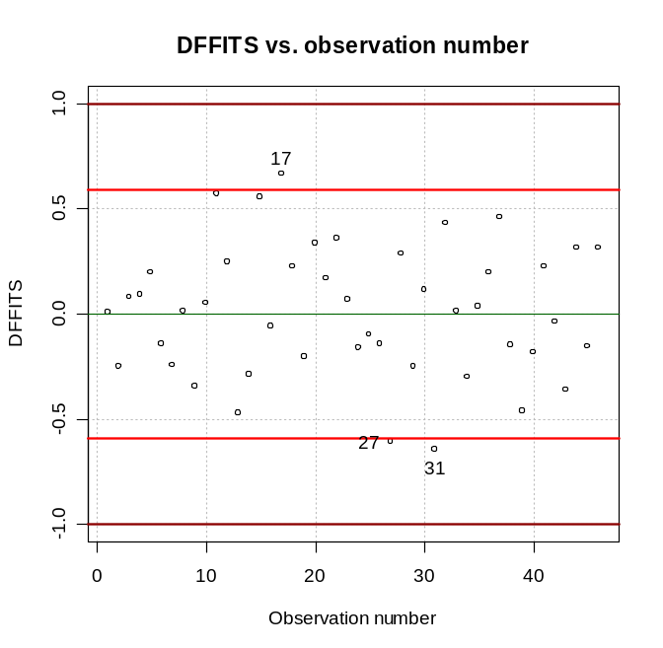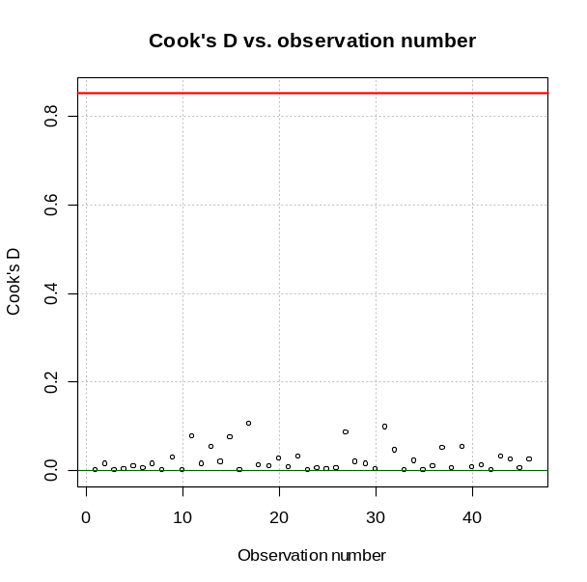
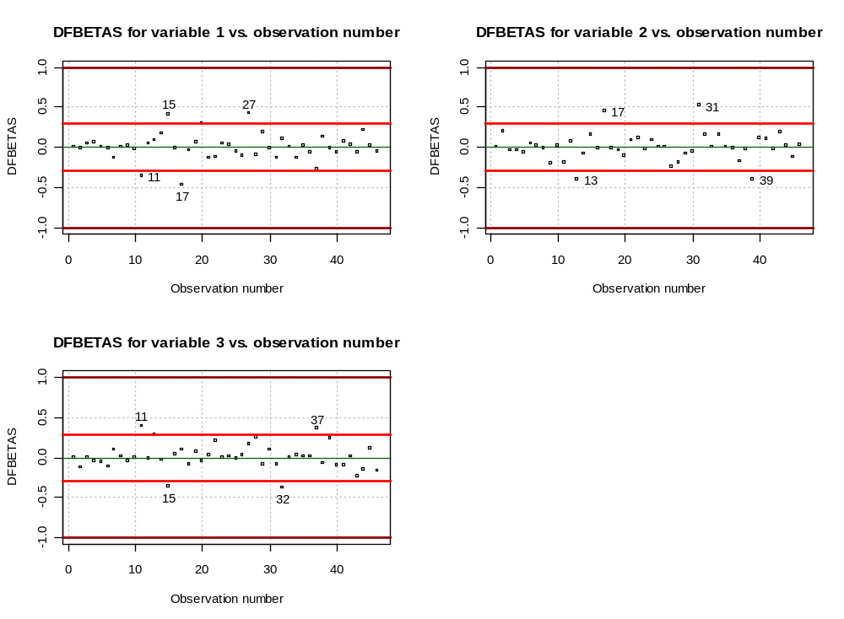

e.

> #Individually – kind of like a DFFIT measure
> mod.fit.wo11<-lm(formula = satisfaction ~ age + illness + anxiety, data =
patient[-11,])
> pred.wo11<-predict(object = mod.fit.wo11, newdata = patient[11,])
> pred<-predict(object = mod.fit, newdata = patient[11,])
> abs(pred.wo11-pred)/pred
[1] 0.02293143

> mod.fit.wo17<-lm(formula = satisfaction ~ age + illness + anxiety, data =
patient[-17,])
> pred.wo17<-predict(object = mod.fit.wo17, newdata = patient[17,])
> pred<-predict(object = mod.fit, newdata = patient[17,])
> abs(pred.wo17-pred)/pred
[1] 0.03614547

> mod.fit.wo27<-lm(formula = satisfaction ~ age + illness + anxiety, data =
patient[-27,])
> pred.wo27<-predict(object = mod.fit.wo27, newdata = patient[27,])
> pred<-predict(object = mod.fit, newdata = patient[27,])
> abs(pred.wo27-pred)/pred
[1] 0.0214488

> #For all observations – this is what the problem is asking for, kind of like a
Cook's D measure
> mod.fit.wo11<-lm(formula = satisfaction ~ age + illness + anxiety, data =
patient[-11,])
> pred.wo11<-predict(object = mod.fit.wo11, newdata = patient)
> pred<-predict(object = mod.fit, newdata = patient)
> mean(abs(pred.wo11-pred)/pred)
[1] 0.01100940

> mod.fit.wo17<-lm(formula = satisfaction ~ age + illness + anxiety, data =
patient[-17,])
> pred.wo17<-predict(object = mod.fit.wo17, newdata = patient)
> pred<-predict(object = mod.fit, newdata = patient)
> mean(abs(pred.wo17-pred)/pred)
[1] 0.01324930

> mod.fit.wo27<-lm(formula = satisfaction ~ age + illness + anxiety, data =
patient[-27,])
> pred.wo27<-predict(object = mod.fit.wo27, newdata = patient)
> pred<-predict(object = mod.fit, newdata = patient)
> mean(abs(pred.wo27-pred)/pred)
[1] 0.01122050

They are not that influential.

f. See my plot in d.

10.17
a. There is moderate pairwise correlation among the predictor variables.
b. The VIF gives a measure of total association between the predictor variables (for example, how is X₁ related to both X₂ and X₃). Below are the VIF values. Because they are not large, there is not a need to worry about multicollinearity.

> vif(mod.fit)
age illness anxiety
1.632296 2.003235 2.009062

  - Answer key:
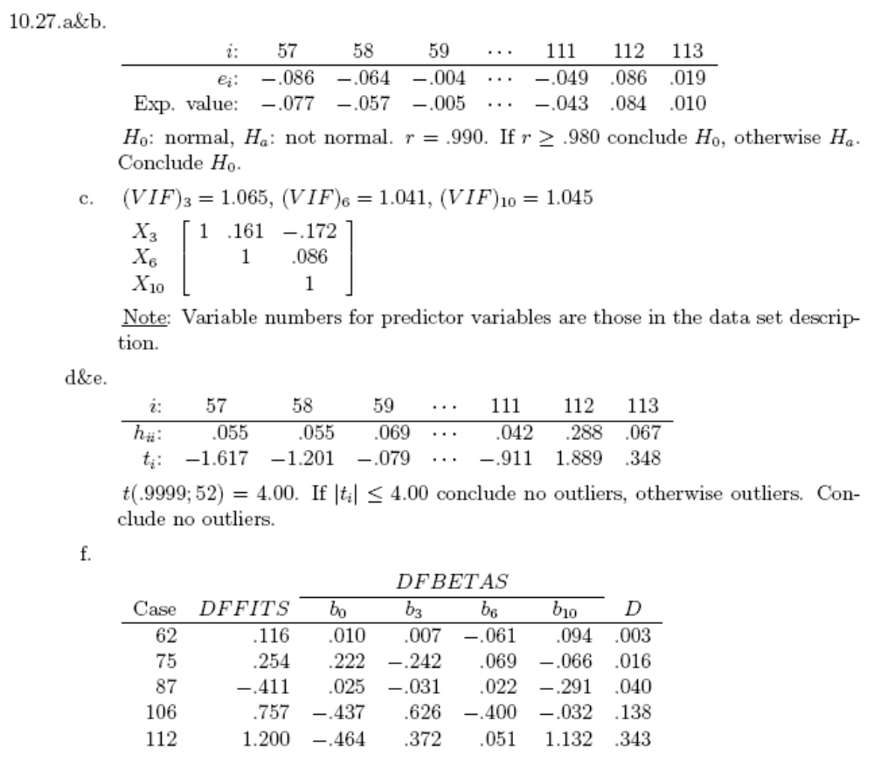
Part of my R code and output:
> #Read in the data
> senic<-read.table(file = "C:\\chris\\UNL\\STAT870\\Instructor_CD\\Data
Sets\\Appendix C Data Sets\\APPENC01.txt", header = FALSE, col.names =
c("ID", "stay", "age", "infection", "culture", "xray", "beds", "school",
"region", "census", "nurses", "facilities"), sep = "")
> mod.fit<-lm(formula = log(stay, base = 10) ~ age + xray + census, data =
senic[57:113,])
> summary(mod.fit)

Call:
lm(formula = log(stay, base = 10) ~ age + xray + census, data = senic[57:113,])

Residuals:
Min 1Q Median 3Q Max
-0.11264 -0.03760 0.01283 0.03365 0.09347

Coefficients:
Estimate Std. Error t value Pr(>|t|)
(Intercept) 6.104e-01 8.881e-02 6.873 7.22e-09 ***
age 3.880e-03 1.627e-03 2.385 0.02069 *
xray 1.175e-03 4.188e-04 2.805 0.00702 **
census 2.926e-04 4.558e-05 6.420 3.86e-08 ***
---
Signif. codes: 0 '***' 0.001 '**' 0.01 '*' 0.05 '.' 0.1 ' ' 1

Residual standard error: 0.05526 on 53 degrees of freedom
Multiple R-Squared: 0.5192, Adjusted R-squared: 0.4919
F-statistic: 19.07 on 3 and 53 DF, p-value: 1.614e-08

> save.it<-examine.mod.multiple.final(mod.fit.obj = mod.fit, first.order = 3,
const.var.test = TRUE, boxcox.find = TRUE, labels = 57:113)

Below are partial answers to the questions. You should elaborate more when answering these questions on your own.

- No modifications are suggested by the plot.
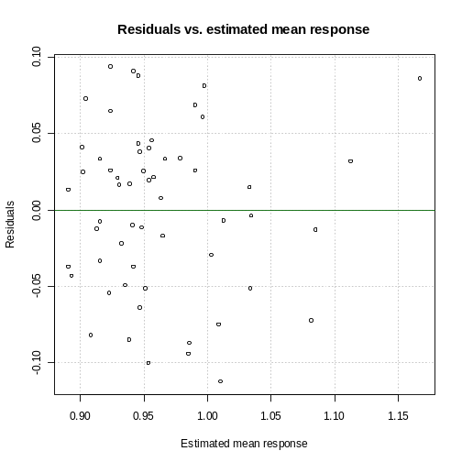

b. There are no large deviations from normality.
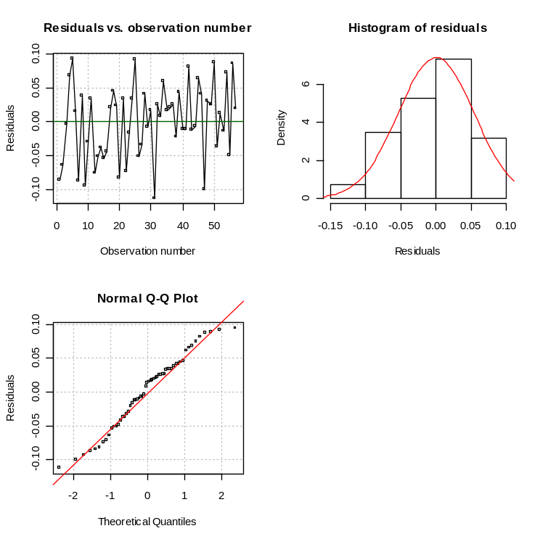

c. No, because the VIF values are close to 1. Similar conclusions can be reached using the pairwise associations given in the scatter plot matrix and correlation matrix.

> #For part c
> scatterplotMatrix(formula = ~ age + xray + census, data=senic, reg.line=lm,
smooth=TRUE, span=0.5, diagonal = 'histogram')
> round(cor(x = data.frame(senic$age, senic$xray, senic$census), method =
"pearson"),4)
senic.age senic.xray senic.census
senic.age 1.0000 -0.0189 -0.0548
senic.xray -0.0189 1.0000 0.0629
senic.census -0.0548 0.0629 1.0000

> vif(mod.fit)
age xray census
1.064693 1.040733 1.044744
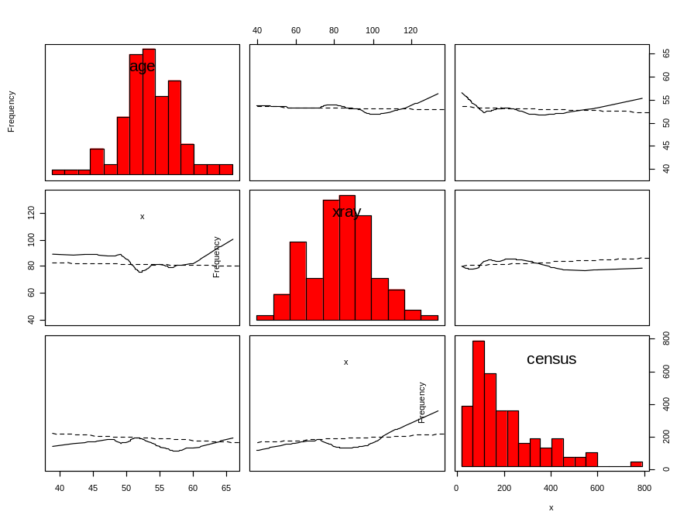

d. There are no outliers present.

> save.it$outlier

max|rstudent| = 2.145014, degrees of freedom = 52,
unadjusted p = 0.03664349, Bonferroni p > 1

Observation: 87
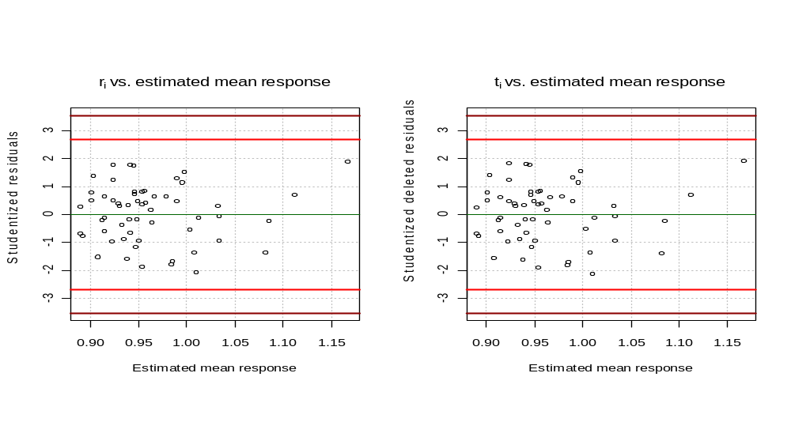

- There are some potentially outlying X observations.

> h.ii<-hatvalues(model = mod.fit)
> p<-length(mod.fit$coefficients)
> n<-length(mod.fit$residuals)
> round(h.ii[h.ii>2*p/n],2)
62 75 102 104 106 112
0.14 0.21 0.15 0.29 0.16 0.29

> plot(x = 1:n, y = h.ii, ylab = expression(h[ii]), xlab = "Observation number",
main = expression(paste("Index plot of ", h[ii])))
> abline(h = 2*p/n, col = "red", lty = "dashed")
> abline(h = c(0.2,0.5), col = "blue", lty = "dotted")

> #identify(x = 1:n, y =h.ii)

> #Use these labels instead
> identify(x = 1:n, y =h.ii, labels = 57:113)
[1] 6 19 46 48 50 56
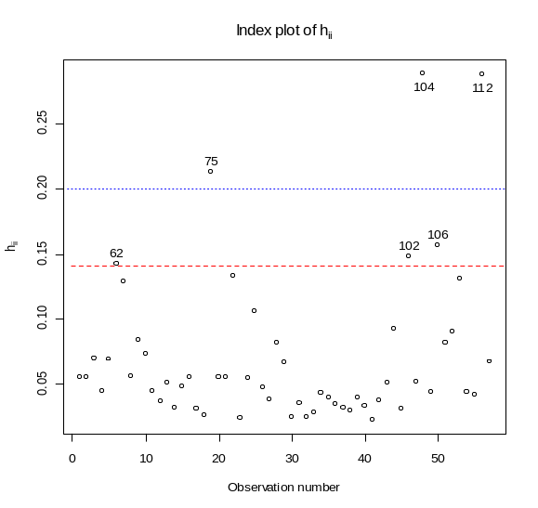

f. I agree with the book regarding 87, 106, and 112.
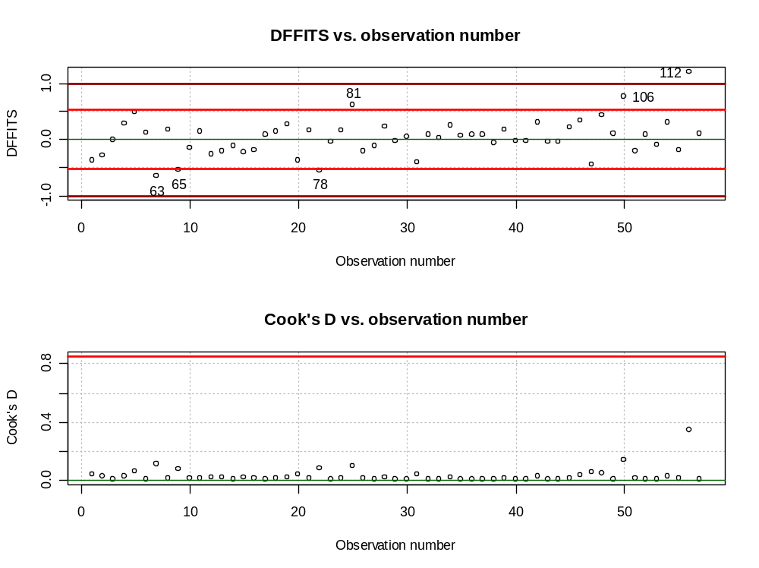
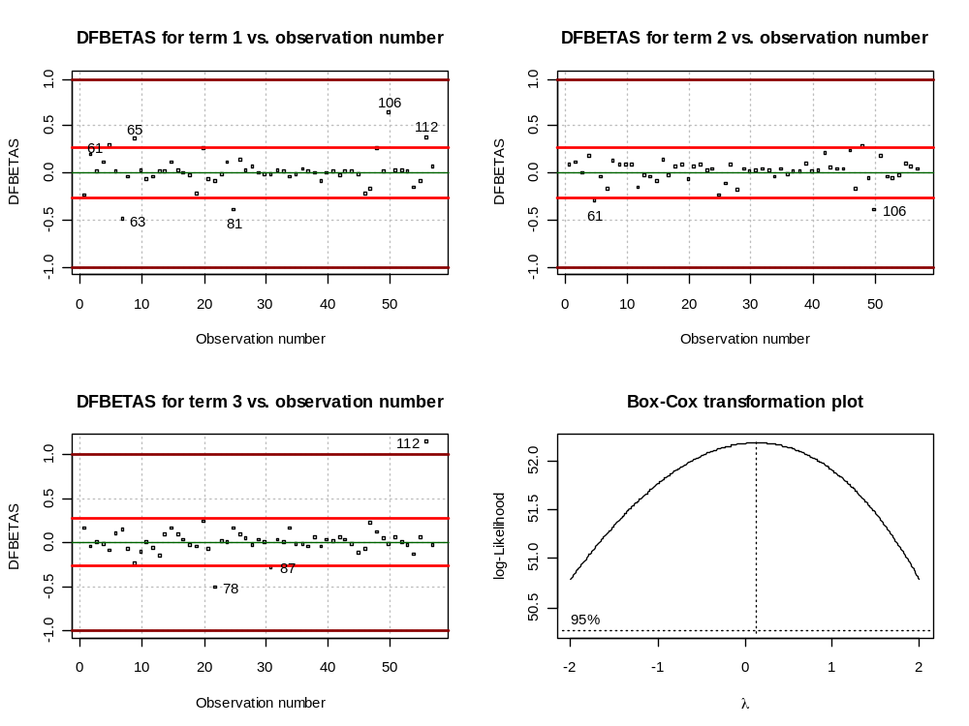

9.27 The model included age, xray, and census.

Answer key:
